**MY SQL Queries:**

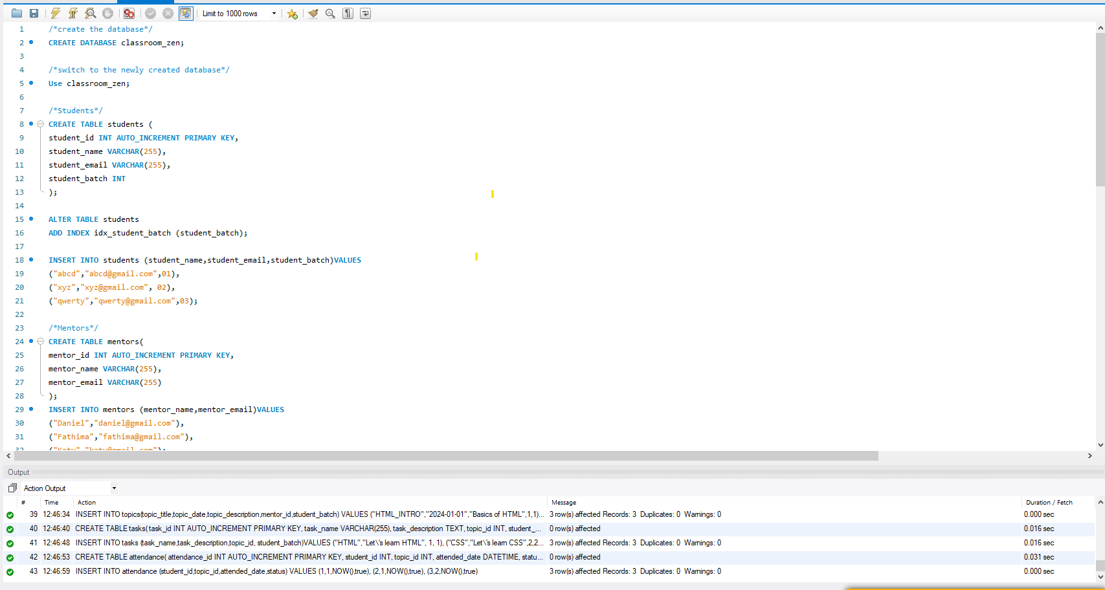

MY SQL EER Diagram:

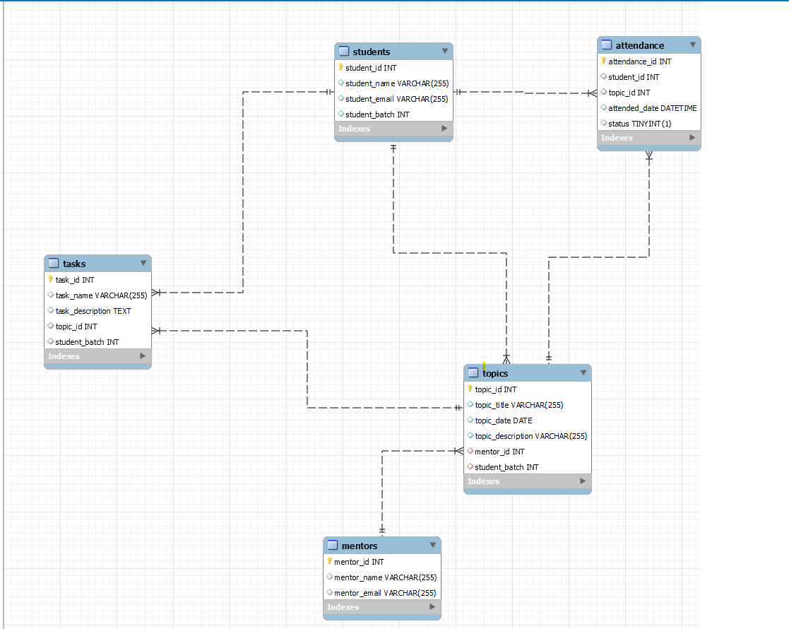

**MYSQL code:**

/*create the database*/

**CREATE DATABASE classroom_zen;**

/*switch to the newly created database*/

**Use classroom_zen;**

/*Students*/

**CREATE TABLE students** (

student_id INT AUTO_INCREMENT PRIMARY KEY,

student_name VARCHAR(255),

student_email VARCHAR(255),

student_batch INT

);

/*An index is created on the student_batch column for faster query execution */

**ALTER TABLE students**

**ADD INDEX idx_student_batch (student_batch);**

INSERT INTO students (student_name,student_email,student_batch)VALUES

("abcd","abcd@gmail.com",01),

("xyz","xyz@gmail.com", 02),

("qwerty","qwerty@gmail.com",03);

/*Mentors*/

**CREATE TABLE mentors**(

mentor_id INT AUTO_INCREMENT PRIMARY KEY,

mentor_name VARCHAR(255),

mentor_email VARCHAR(255)

);

INSERT INTO mentors (mentor_name,mentor_email)VALUES

("Daniel","daniel@gmail.com"),

("Fathima","fathima@gmail.com"),

("Katy","katy@gmail.com");

/*Topics*/

**CREATE TABLE topics**(

topic_id INT AUTO_INCREMENT PRIMARY KEY,

topic_title VARCHAR(255),

topic_date DATE,

topic_description VARCHAR(255),

mentor_id INT,

student_batch INT,

FOREIGN KEY (mentor_id) REFERENCES mentors(mentor_id),

FOREIGN KEY (student_batch) REFERENCES students(student_batch)

);

INSERT INTO topics(topic_title,topic_date,topic_description,mentor_id,student_batch) VALUES

("HTML_INTRO","2024-01-01","Basics of HTML",1,1),

("CSS_INTRO","2024-02-02","Basics of CSS",2,2),

("REACT_INTRO","2024-03-03","Basics of REACT",3,3);

/*Tasks*/

**CREATE TABLE tasks**(

task_id INT AUTO_INCREMENT PRIMARY KEY,

task_name VARCHAR(255),

task_description TEXT,

topic_id INT,

student_batch INT,

FOREIGN KEY (topic_id) REFERENCES topics(topic_id),

FOREIGN KEY (student_batch) REFERENCES students(student_batch)

);

INSERT INTO tasks (task_name,task_description,topic_id, student_batch)VALUES

("HTML","Let\'s learn HTML", 1, 1),

("CSS","Let\'s learn CSS",2,2),

("REACT","Let\'s learn REACT",3,3);

/*Attendance*/

**CREATE TABLE attendance**(

attendance_id INT AUTO_INCREMENT PRIMARY KEY,

student_id INT,

topic_id INT,

attended_date DATETIME,

status BOOLEAN,

FOREIGN KEY (student_id) REFERENCES students(student_id),

FOREIGN KEY (topic_id) REFERENCES topics(topic_id)

);

INSERT INTO attendance (student_id,topic_id,attended_date,status) VALUES

(1,1,NOW(),true),

(2,1,NOW(),true),

(3,2,NOW(),true);